**DAILY ONLINE ACTIVITIES SUMMARY**

|  |  |  |  |  |  |  |  |  |
| --- | --- | --- | --- | --- | --- | --- | --- | --- |
| **Date:** | **15/06/20** | | | | | **Name:** | **SARANG VK** | |
| **Sem & Sec** | **8th B** | | | | | **USN:** | **4AL16CS085** | |
| **Online Test Summary** | | | | | | | | |
| **Subject** | | **SMS** | | | | | | |
| **Max. Marks** | | **60** | | **Score** | | | **12** | |
| **Certification Course Summary** | | | | | | | | |
| **Course** | 1. [Introduction to R](https://olympus.greatlearning.in/courses/10912) | | | | | | | |
| **Certificate Provider** | | | **GREATLEARNING** | | **Duration** | | | **28 MINUTES** |
| **Coding Challenges** | | | | | | | | |
| **Problem Statement:** Python Program to Remove Punctuations From a String | | | | | | | | |
| **Status:COMPLETED** | | | | | | | | |
| **Uploaded the report in Github** | | | | | **YES** | | | |
| **If yes Repository name** | | | | | **alvas-education-foundation/sarang_vk** | | | |
| **Uploaded the report in slack** | | | | | **YES** | | | |

Certification Course Details: (Attach the snapshot and briefly write the report for the same)

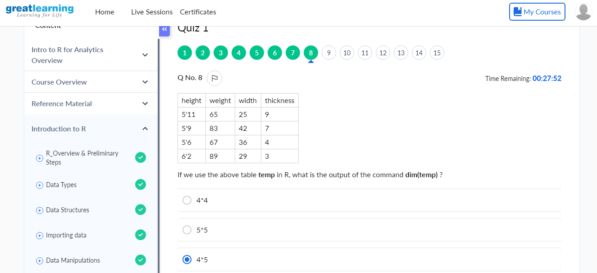

Coding Challenges Details: (Attach the snapshot and briefly write the report for the same)

Coding was given n it was uploaded for github and slack

Coding Challenges Details:

**Program no:1**

punctuations = '''!()-[]{};:'"\,<>./?@#$%^&*_~'''

my_str = "Hello!!!, he said ---and went."

no_punct = ""

for char in my_str:

if char not in punctuations:

no_punct = no_punct + char

print(no_punct)